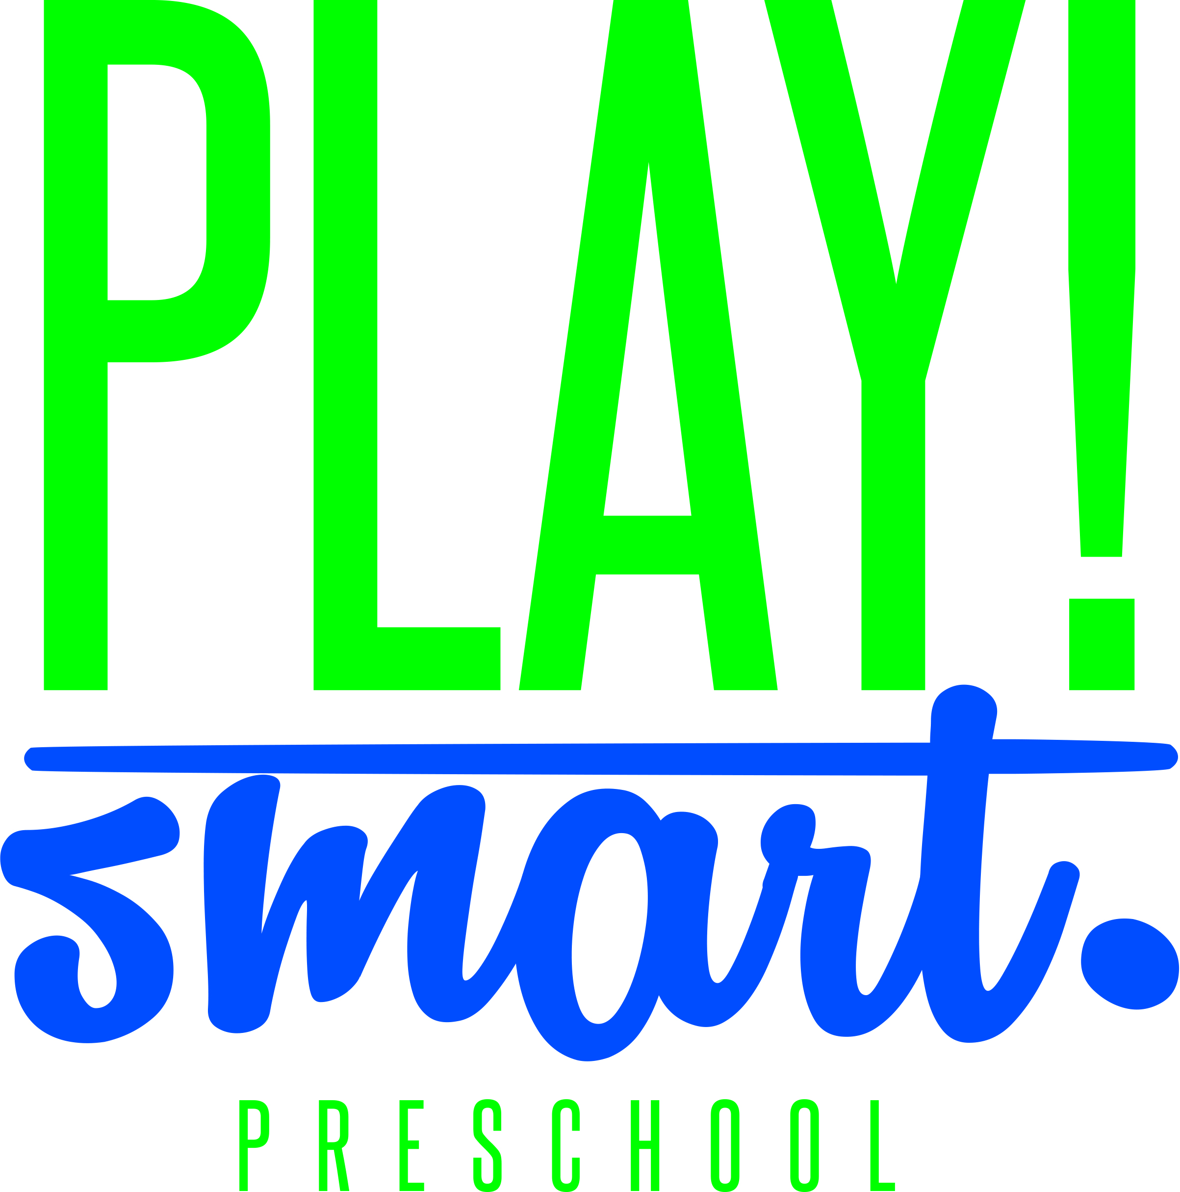

Parent Handbook
Required reading for families enrolling
Information and Policies

This handbook was prepared to introduce parents to Play Smart Preschool, and to the responsibilities we jointly assume in creating an optimal learning environment for our preschoolers.
The success of our program depends upon the cooperative efforts of parents and staff.
PLEASE READ THIS HANDBOOK CAREFULLY
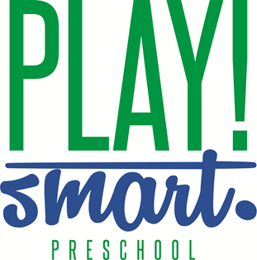

Dear Parent/Guardian:
Everyone here at Play Smart Preschool would like to extend a warm welcome to you and your child. The purpose of this handbook is to explain our philosophy, practices, and policies.
We believe in providing a safe, clean, healthy and educationally stimulating environment that is conducive to meaningful learning experiences. Activities in our early childhood program are both age appropriate and individual appropriate. In other words, the programs are tailored to meet the needs of children so that they may develop to their fullest potential. Initiating play in a stress-free environment will enable them to learn and explore their world and interests.
We encourage communication between staff and parents / guardians and love to share stories about your child’s experiences. We encourage you to share your thoughts, questions, or concerns with us. We invite you to visit, observe and even participate in your child’s early experiences, whenever possible. Most of all, we want to become partners with you in the healthy development of your child.
We would like to THANK YOU for your support and showing your confidence in Play Smart Preschool.

Sincerely,
Jill Payne
Trina Pryor
Play Smart Preschool Owners

STATEMENT OF NON-DISCRIMINATION
Play Smart Preschool welcomes all families, regardless of race, religion, national origin, sexual orientation, gender, ancestry, marital or parental status, and physical, mental, emotional or learning disability.

School Philosophy
It is the philosophy of Play Smart Preschool that children are encouraged to learn and grow by providing a foundation of developmentally appropriate experiences where all children can succeed in a safe and nurturing environment.

We believe that each child is a unique individual and that all children can learn. Our preschool programs provide inclusive settings that recognize children’s varied abilities, interests, needs, and learning styles.

We believe children learn best through meaningful play. Our play-based, child centered program reflects the integration of physical, cognitive, social, emotional, language, self-help and aesthetic areas for the total development of the child. Meaningful play encourages curiosity, discovery and problem solving which allows individual growth and development of a positive self-image.

We recognize that parents are the child’s first teachers. Children learn best when parents are involved in their educational program. The primary bridge between home and school is the involvement of family and community.

Curriculum
Play Smart Preschool embraces the developmental philosophy of learning, which respects each child as a unique individual, and supports the knowledge that young children learn best through play and hands-on experiences.

Through daily classroom activity we strive to maintain a BALANCE between:
- Child-directed and Teacher directed activity
- Structure and flexibility
- Group needs and individual needs
- Program goals and children’s interests
- Security and risk-taking
- Familiarity and challenge

DAILY ACTIVITY OFFERING
ALWAYS INCLUDES:
- Creative Arts
- Blocks
- Dramatic Play
- Sensory Materials
- Manipulatives
- Science
- Literature
- Music and Movement
- Snacks
- Outdoor Play

At Play Smart Preschool, our curriculum is…
- Developmental: Children's learning and skill acquisition is by nature, but develops at the child’s own pace. Each child is respected and supported at each stage of development as they progress toward their own goals and potential.
- Play-based: Play is the child's natural process for learning and development. Within play’s natural learning environment children develop socially, emotionally, physically, and intellectually.
- Child-directed: Children learn best when they have some control over their learning, when activities are meaningful and relevant, and when they make choices regarding what materials they use and how they will use them. These choices empower children to take control of their own learning and to become intrinsically motivated – the most effective and engaging way to learn.
- Teacher-supported: Rather than a dispenser of knowledge, the teacher is primarily a facilitator enabling the child to learn from his/her own experience. The teacher prepares a nurturing environment, a wide variety of material and activity, and ample opportunity to explore.
- Integrated: Curriculum includes all parts of the preschool day, including arrival, routines, care taking transitions, and departure as well as planned activities and spontaneous play. Learning occurs in all areas of the classroom and is not an isolated event, drill, or activity.
- Emergent: Curriculum is created daily as the children's interests and ideas are freely explored. When encouraged to make their own choices, explore their own ideas, and to follow their own interests, children are involved in the real process of discovering knowledge.
Policies and Procedures
Enrollment Procedures
Play Smart Preschool accepts students from ages 3 years through 5 years. Classroom size is 18 or less children at a time.
Applications and a yearly registration fee per child shall be submitted prior to 1st day of attendance. There will be a waiting list for any class with more applications than spaces.
In compliance with licensing regulations, registration and emergency forms must be received prior to any child’s admission to the classroom. All other health and immunization records shall be submitted at this time as well. Children whose forms have not been received by the designated deadline may be excluded from the classroom until such forms have been received.
The first 30 days of preschool is considered a probationary period. If it becomes evident during this period that the relationship between the school and the family is not mutually beneficial, the child may be dropped from preschool enrollment. In the event a child is dropped from enrollment, tuition costs will be pro-rated and a refund will be given if applicable.
If at any time, either the parent or the preschool feels that the relationship between school and family is not mutually beneficial, either party may call a special conference. Participants at the conference may include the parents involved, the teacher and the director.
Enrollment of Children with Special Needs
It is the policy of the preschool that children with special needs be included in enrollment when it is determined that the staff and /or facility can provide a beneficial classroom setting for this child. At the time of application to the preschool, parents shall be required to fully disclose any known special needs of his/her child. It is the prerogative of the school to request that the child be evaluated prior to admission to the school and that any medical, education or other pertinent records be offered to the school for consideration.
Withdrawal Procedures
Families must complete an Early Withdrawal Form (available in office) 30 days in advance of withdrawing a child prior to the end of the school year.
- A $100.00 early withdrawal/administrative fee is due with the form to release you from your remaining monthly financial obligations.

Extended Leave
Play Smart Preschool expenses do not change when individual students take an extended leave of absence from the classroom. Therefore, tuition payments must be made in full during extended leaves. Or, a child may voluntarily withdraw pursuant to the terms of withdrawal procedures. If space is available, the child may re-enroll and a new registration, equipment and retainer fee would not be required. The preschool offers no guarantee that openings in the classroom will not be filled during the time a student has voluntarily withdrawn.
Tuition and Fees / Class Schedules
- Registration / Supply Fee: $100.00 must accompany enrollment applications to be considered for admission. A $50.00 supply fee prior to the first day of school is also required. These fees are non-refundable.

- Monthly Tuition: The 1st payment is due by August 1. All other payments will be debited on or the first business day after September 1st, October 1st, November 1st, December 1st, January 1st, February 1st, March 1st, April 1st, May 1st
- Parents are responsible for making payments on time. A checking or savings account debit authorization form is required. All tuition payments will be deducted using this method.

- Late Payment Fee:
  - Any ACH payment rejected for any reason, including user cancellation, insufficient funds, etc., will be charged a $35 bank fee.
  - If any payment is more than 5 days late, you will be charged a $25 late fee.

- Monthly Tuition Rates:
  - Monday and Wednesday and Friday - $275 / month
  - Tuesday and Thursday - $180 / month
  - Monday, Tuesday, Wednesday, Thursday, Friday - $325 / month
  - Afterschool Rate - $225.00 / month

- Tuition is not pro-rated during any month, regardless of holidays or other non-school days.
- Early Withdrawal fee: $100

School Closings
Play Smart Preschool will follow Owensboro Public Schools for closing regarding weather-related or poor road conditions. Play Smart Preschool will be closed the 1st day Owensboro Public Schools are closed for weather and will reopen the next business day, unless the Owner(s) declare it to be unsafe. In the event that school needs to be canceled for any reason, the Owner(s) shall notify each family by email/text/phone/social media.
We will offer makeup days. We will typically use the same makeup days as Owensboro Public Schools.
School Communication
Director: Amanda Sprouls
E-mail: Amanda.playsmartky@gmail.com
Phone: 270-240-3310 (school phone)
Phone: 1-314-803-5659 (cell phone)
If a child will be absent, please notify his/her teacher by calling the school phone or the director.
Monthly Newsletter-
Distributed monthly, this publication provides important information regarding classroom activities, important dates, and other general information. Please take a few minutes each month to read our newsletter – our most important vehicle for communicating school activity. If at any you would like to have something valuable to other families printed in the newsletter, please contact the Owner / Director and it will be forwarded to the Newsletter editor.
Parent Folders
Each student will be provided a canvas bag on the first day of school. In the bag will be a folder that will remain in the bag throughout the year. This folder will contain activities completed by your child as well as pertinent information. Please check this daily and make sure the child returns it on the next school day. Parents may also return information to the school inside this folder.
Parent Meetings/Conferences
Meetings can be requested at any time by the parents. We will have 2 scheduled parent meetings a year, in the fall and May. At these meetings we will discuss your child’s development and progress in the classroom with their teacher.
Parent Bulletin Board
Located in the hallway outside the room. Please check this board for school information, including our activity calendar.
By Phone / Email
Please be sure that your phone number and email address (if applicable) are kept current on your class roster. We encourage the use of text / email when possible to communicate with parents and staff.
Teachers are available by phone and/or email as needed to discuss classroom issues or concerns regarding your child. Staff requests that calls, when possible, be made during regular office hours unless your need is urgent. Individual conferences may be scheduled at any time, as needed.
In addition to communicating school information to parents – we would like to hear from you as well. If you have questions, concerns, or a great idea, please contact our program director at any time.
Health and Safety Guidelines
HEALTH GUIDELINES
In an effort to create a healthy and safe preschool environment, all families must abide by the following rules. Any family failing to meet any of these Health Guidelines may be dismissed from Play Smart Preschool.
- Complete registration, emergency forms, health and medical records and turn in to the Admissions Chair before the first day of school.
  - Insure your child’s immunizations are current.
    - IF CHILD IS FULLY IMMUNIZED- Complete Certificate of Immunization form and turn in to office
    - IF CHILD IS NOT FULLY IMMUNIZED – If you have chosen not to immunize your child, your responsibilities are listed below:
      - Statement of Exemption to Immunization Law printed on the reverse of the Certificate of Immunization form must be filled out and given to Owner. Please be sure to list any immunizations your child has had on the front of the form.
      - You must be completely knowledgeable on the symptoms of any diseases your child has not been vaccinated for. If your child exhibits any of the symptoms of these diseases, you must notify the Owner immediately.
      - Be prepared to keep your child out of school until the Doctor determines it is safe for your child to return. Understand in advance that this time period may be as long as 2 months, depending on the circumstances.
- Keep your child out of school if you exhibit any of the symptoms of contagious illnesses listed below (please notify staff of your child’s absence):
  - Fever of 100 degrees F (axillary)/or 101 degrees F (orally) or higher within 24 hours
  - Thick, colored nasal discharge
  - 2 or more loose, watery stools within 24 hours
  - Thick, colored drainage from the eyes
  - Vomiting on 2 or more occasions within 24 hours
  - Within 24 hours of starting any antibiotics
  - Any evidence of lice
  - Any unusual rashes, not associated with diapering, heat or allergies
**Often the spreading of illness occurs before severe symptoms occur, i.e. fever, vomiting, etc. Observing your child’s behavior is the key way to detect the possible onset of an illness. It is up to you to keep your child home if you believe he /she is coming down with something other than a common cold.
- CHICKEN POX POLICY: If you know your child has been exposed to chicken pox, inform the owner immediately according to the guidelines listed above.
- Be overly cautious in regard to hand washing both adults and children at school. Hands should be washed at the following times:
  - Upon arrival at school, we require that all children to wash their hands before coming into the school
  - Prior to handling or eating food
  - After using the toilet
  - After blowing nose
- Apply sunscreen as needed before class for everyday outside play, licensing does not allow us to apply sunscreen without written permission from a Doctor.
Medication Procedures and Storage
- As a general rule, medications are not administered at preschool. In an event that your child needs medication while at school, it must be stored in the designated medicine box located in the office out of the reach of any children. The box should be locked; a teacher will know where the key is located.
Illness, Accidents, and Injuries
Sick children cannot be cared for at school. If a child becomes ill (refer to contagious symptoms listed above) while at school, parents will be notified immediately. The child will be isolated from the group and comfortably cared for and supervised until parents arrive.
In the event of an accident or injury, which requires medical attention, staff shall immediately notify parents and/or medical personnel as instructed in writing by the parent.
Toilet Training
At Play Smart Preschool, we do not require that your child is toilet trained to attend our preschool. It is preferable that they are able to use the restroom and wash their hands alone, but together we can take extra measures to make them comfortable at school and guide them to be self-sufficient. If this is a concern, please discuss it with the teachers or director so we can develop a plan of action together. We may ask for any needed assistance if your child soils themselves during their day.
SAFETY GUIDELINES
The following procedures are required by the State health and human services guidelines.
Emergency Procedures
Tornado drills shall be performed once a quarter. If a tornado warning is issued, parents are advised not to pick up their children until the warning is over. Children will remain in a place of safety at the school until the warning is lifted.
Fire drills shall be performed once a month. Evacuation plans are posted and fire alarm equipment shall be utilized during drills.
In the event of a fire or emergency other than a tornado, children will be evacuated to a safe area and parents shall be promptly notified. Staff will remain with the children until the emergency has passed and class has resumed, or until parents have picked up their children.
Head Count of Children
The staff at the preschool is responsible and required to take a headcount of the children in the class in accordance to the enrollment record at the beginning of the class. It is suggested that each teacher identifies where every child is every 15 minutes in addition to every time there is a change in play—Outside to Inside, Snack to Book Time, etc.
Child Picked Up After Closing or Not Picked Up At All
We ask that you arrive on time to pick up your child from preschool. If you are running late, please give us a quick call so we can inform your child and alleviate any concerns. Be assured that your child will not be left at the school until someone has arrived to pick them up. If there is no contact by the parents and the class is over, we will call the numbers on the emergency contact list until we have reached someone that has been authorized to be responsible for the child. In the event that no one can be reached and we have put forth sufficient effort, the local police department will be notified.
Reporting Child Abuse
Child abuse is generally defined as non-accidental, physical, or mental injury caused by the acts of omissions of the child’s parents or caretakers, including physical abuse, neglect, emotional maltreatment and sexual abuse. As required by law, any staff member who has reasonable cause to know or suspect that a child has been subjected to abuse, must immediately report such fact to the county department of social services or local law enforcement agency at the following address:
Kentucky Cabinet For Health and Family Services
3649 Wathens Crossing
Owensboro, KY 42301
(270) 687-7491
1-877-597-2331

Visitors to the Center

Please note that any visitors to our center must sign in at the front desk. This is a state requirement as well as a Play Smart Preschool Policy. We need to keep track of observers or other persons that cross through our doors. Make sure you monitor this situation on your helping parent day along with our staff.

Release of Children

The children at Play Smart Preschool will only be allowed to leave with their parents and the people that have been authorized on their emergency consent form. Two pick up tags will be provided to each family. It will be required that the person picking up your child shows the pick-up tag, or may show their id. It is your responsibility to inform any person that may be unfamiliar, that they will be required to present identification of the release of the child and the parents may be called to confirm the release. Please let the teachers know ahead of time if we should expect an unfamiliar face to come for your child.

Ground Rules for Children
- Plenty of rest a good breakfast or lunch, and an unhurried routine will help insure that your child functions at his/her best
- It is suggested that your child be at school ON TIME. Our school day begins at 8:00 am. This will help ease your child into our daily routine - it is much more difficult to join an activity or group of children already 'in progress'.
- We require that your child to wash their hands before they enter the play area for class, this will help us to keep germs at a minimum.
- PLEASE SEND YOUR CHILD TO SCHOOL IN PLAY CLOTHES! Wearing clothes that 'cannot get dirty' will inhibit your child's interactions with materials.
- Tennis shoes or other sturdy shoes are preferable.
- We plan to play outside as often as reasonable, therefore please dress your child for the weather. This includes coats and hats.
- Generally, toys from home are discouraged. If your child needs to bring something from home to help make the transition to school he/she will be encouraged to keep it in his/her school bag.
Ground Rules for Parents
- Accompany your child into the classroom, sign the attendance form, check bulletin boards and folders for important communications.
- If you arrive prior to class, please wait in the hall entry until classroom doors are opened. The teacher needs this time to prepare the classroom. This would be a great time to wash hands before coming into the class.
- Please inform your child's teacher of anything which might affect your child's behavior in school--lack of sleep, upsets at home, out of town, company, etc. This knowledge will help teachers to better understand your child's behavior and adjustment to the classroom.
- Please say good-bye to your child before leaving. 'Sneaking out' to avoid separation issues generally magnifies the problem and can result in loss of trust between parent and child. Teachers will be happy to assist you should you have problems with separation.
- Arrival and dismissal times are generally not good times for teachers to talk at length with parents. Our place is with the children at these times. If you have questions or concerns that will take more than a minute to discuss, please schedule a convenient conference time.
- Members of carpools must be sure to authorize the release of their child to other carpool drivers on the pertinent school forms. Please check the folders and cubbies of all children in your carpool so that important information is carried home daily. Be sure to sign in or out all children in your carpool upon arrival and dismissal.
- Please allow us to 'close' our class time together without interruption. You may wait outside the classroom or join us as needed until dismissal.
- Please check and clear out cubbies and parent folders after each class.
Snack Time
- Please inform classroom teacher of any allergies or food restrictions.
- Play Smart Preschool will provide a nutritious snack for your child daily.
- Water or Milk will be provided to drink (please inform teacher of any dairy allergies)
- Children love to cook and are capable of helping in many ways. On certain days the children will prepare their own snacks with the help of the teacher / teacher assistant.
- You can bring your child a snack from home, but please keep it simple and nutritious.
- For special occasions (Birthdays) parents / guardians are allowed to bring a special treat for the entire class. First please check with the teachers on any allergies.
Lunch Time
If your child is staying for after-school, he/she is required to bring a lunch. Please be sure to include an ice pack in your child’s lunch box. While we will assist the children in opening their packages, we do ask that the lunches are pre-portioned and in child-friendly packages.

All lunches must contain the following per state guidelines:
- Bread
- Milk
- 2 vegetables, 2 fruits OR a fruit and a vegetable
- Protein
- We prefer that you do not pack any candy or sweets.
- All lunch boxes and cups brought to school should be labeled with child’s name.
- Lunches cannot be warmed in the microwave. You may bring a thermos to keep your child’s lunch warm.
Guidelines for Disruptive Behavior in the Classroom
Treat all children with dignity and respect, taking into consideration each child’s special needs. Corporal or harsh punishment of any kind is not permitted at Play Smart Preschool.
- If a child is being unruly or disruptive, discreet re-direction is always the first option.
- If 2 or more children dispute possession of an object, the goal is to give the children words to solve the problem. The adult role should be a mediator, to encourage each child to verbalize his/her view of the problem. Help them determine an agreeable solution on their own when possible, rather than the adult setting the course of action.
- If a child is exhibiting aggressive behavior toward another child…firmly state, “I cannot let you [bite, hit push, etc]. It is time for you to make a different choice to play with something else. Can you choose or do you need my help?
Thank you for choosing Play Smart Preschool for your child. Please let us know if you have any questions or need assistance with anything.
Trina Pryor
Jill Payne

